Author: Nguyen Hong Son (sonnh_a04688)

Guideline for Tortoise SVN using

Download install file follow below link and then install
http://tortoisesvn.net/downloads.html

Action steps:

_ You create a new folder to store all data from code.google.com (recommend you should create it at easy manipulateable place).

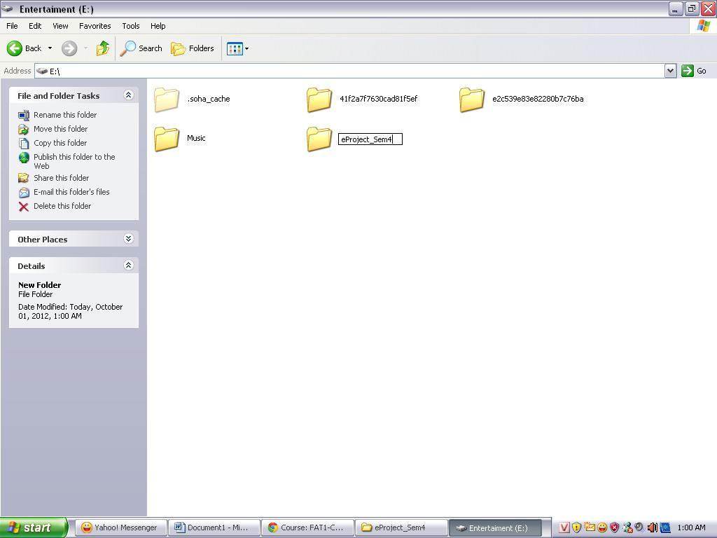

_ Right-click and choose SVN Checkout
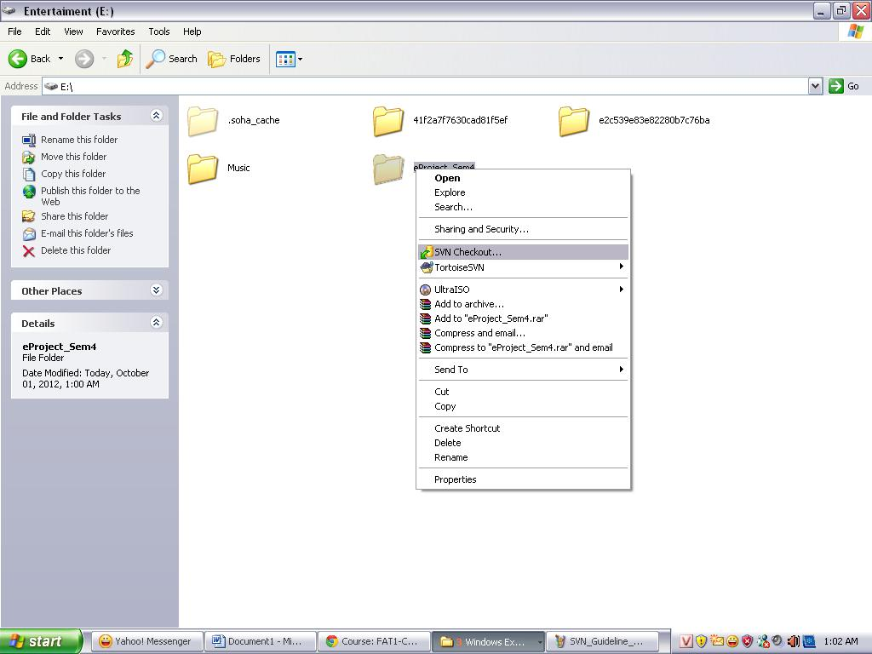

_ Fill this link https://aptech-project-jsp.googlecode.com/svn/trunk/ to URL of respository
_ Check out directory: you browse to folder you have created above
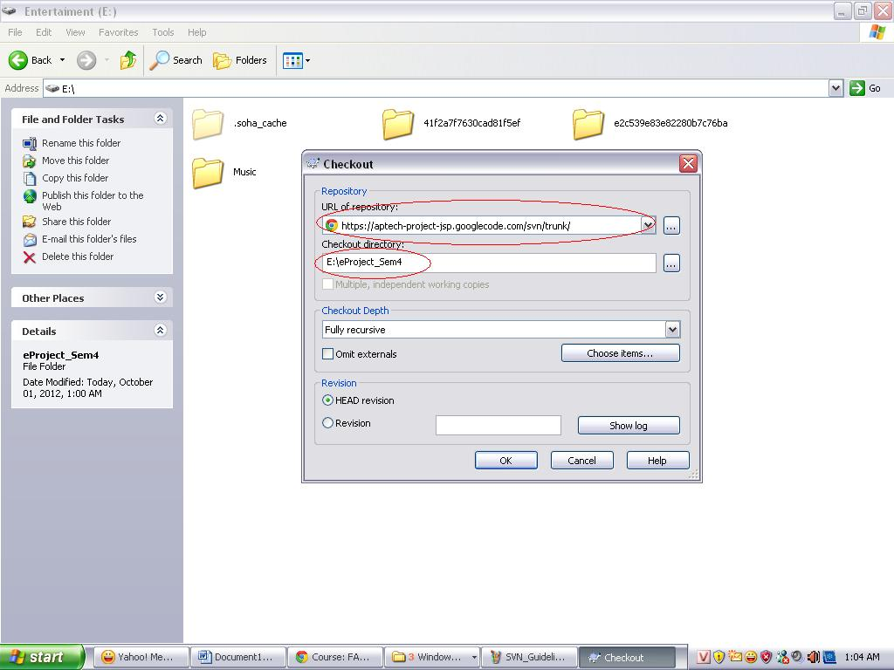
_ Click OK and then you will see hidden folder .svn in folder. It’s successful.
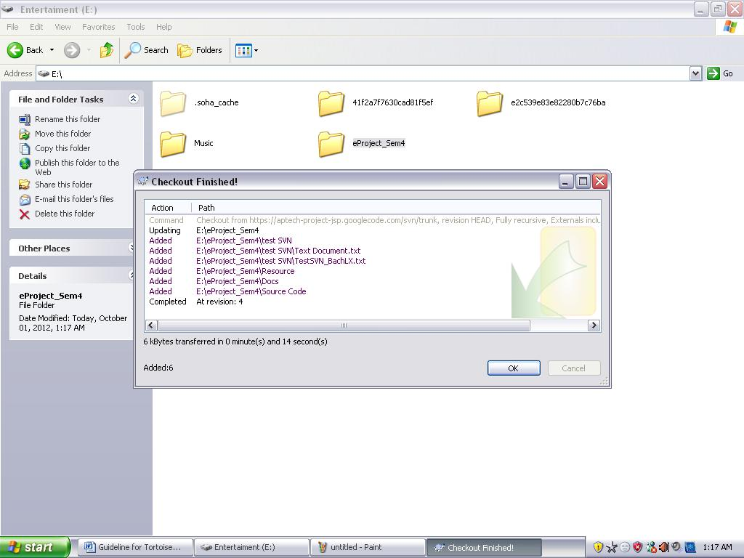
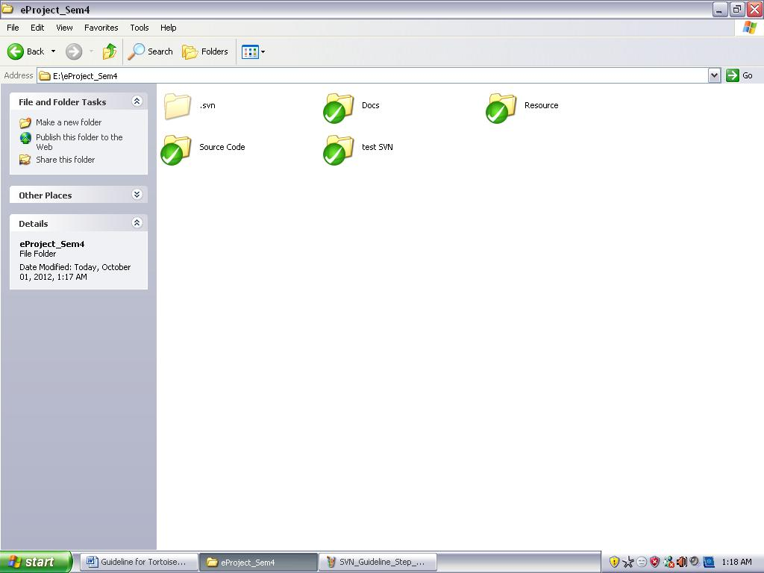

Add and commit action
_ When you have new files in folder, if you want to up it to server, you must follow below steps:
+ Right-click and choose Add
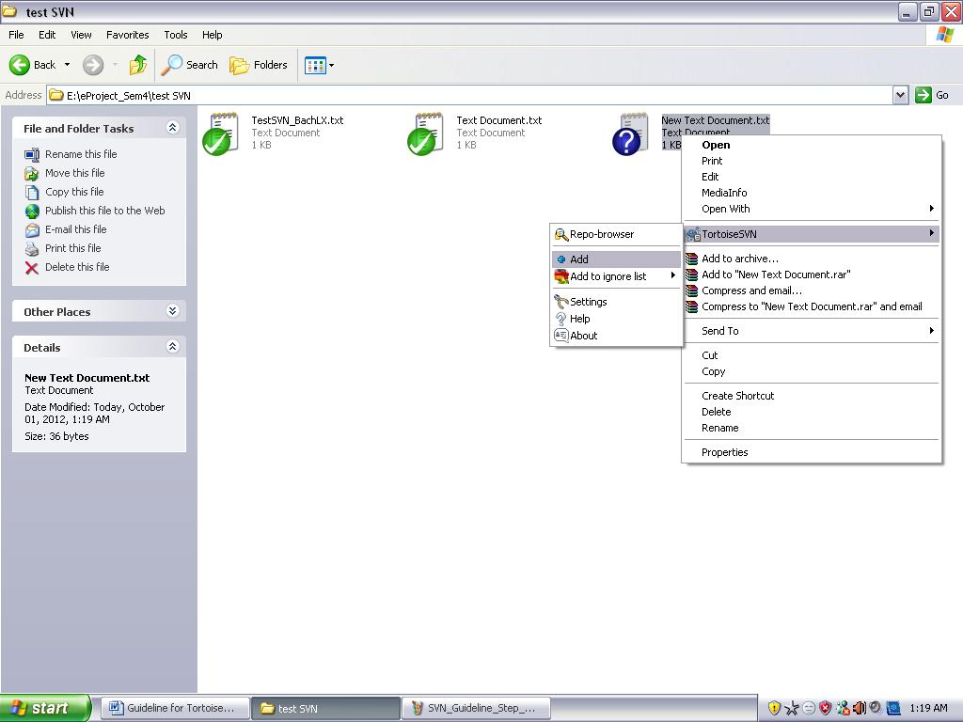
+ Right-click and choose SVN Commit.
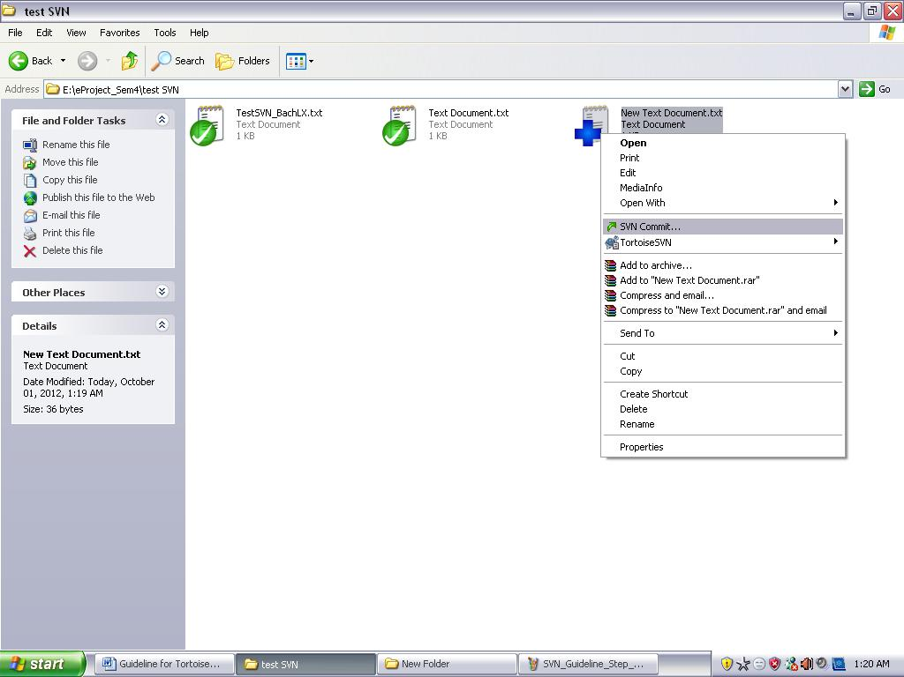
+ Write Recent Message (it’s important)
Rule:
‘+’ : use for adding a new file
‘-‘ : use for removing file
‘*’ : use for fixing bug/error
‘!’ : use for updating file
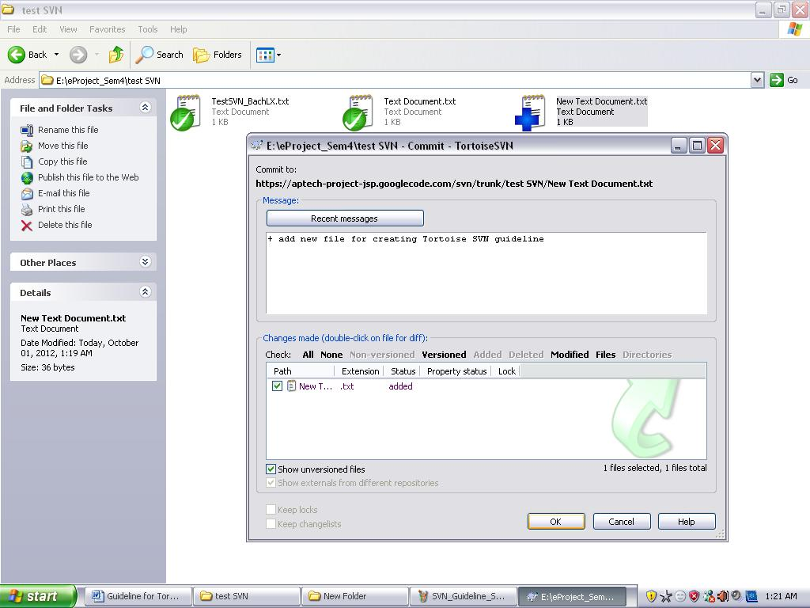

_ If you commit the first time, server will request you fill username and password, these informations will be provided by server.
Username: nhsonit87@gmail.com
Password: qV8py8xV6rN9
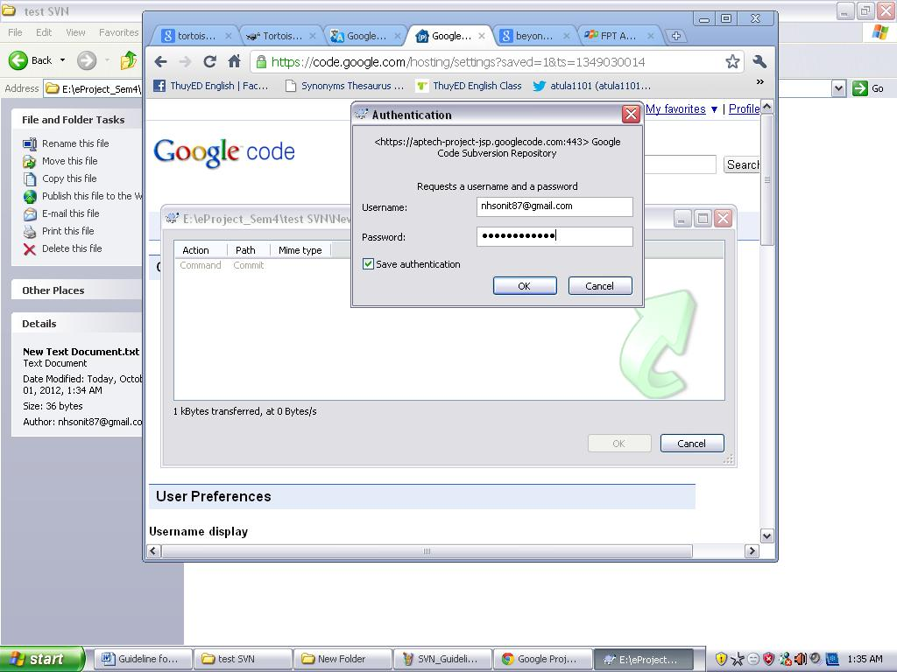

Update action:
_ Right-click and choose SVN Update
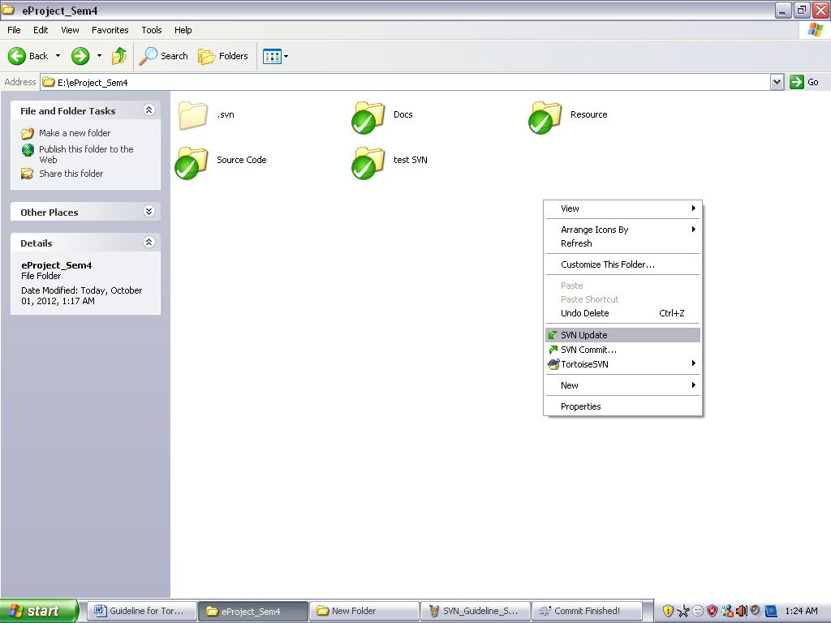
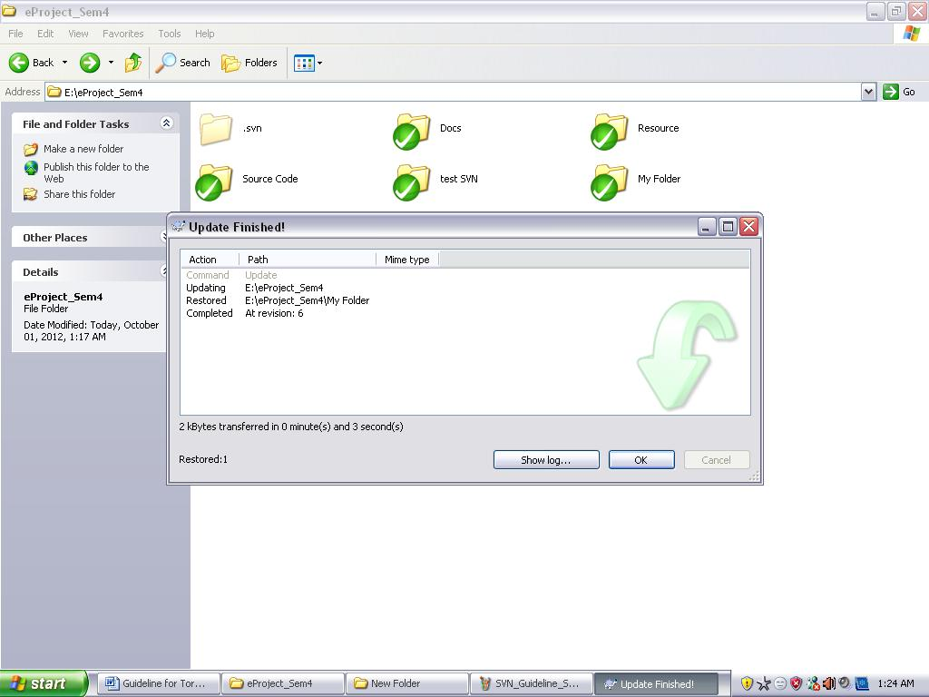

Note:
_ This action will take the lasteset verion from server to your computer but it’s easy to make a conflict with the changed file in your computer during you code or fixing something in project.
_ So you should not do this action for updating root folder until you understand it clearly (recommend)
_ I will show you clearly when we are in meeting.

